My growth in visual communication was subtle, but important. I discovered the power of alignment of objects in presentations. Before, objects in my presentations were roughly thrown around out of laziness. There were few definite shapes or flow. In the presentations in this course, I aligned pictures and text to be visually appealing.

The slide below is a part of my most polished presentation yet. The title accurately describes the topic of the slide. This helps clue the audience in. A clueless audience is no audience at all. The picture is relevant, displaying a real artifact that illustrated my points. The caption is sufficiently concise to effectively describe the artifact. Notice the center alignment, creating a natural progression.

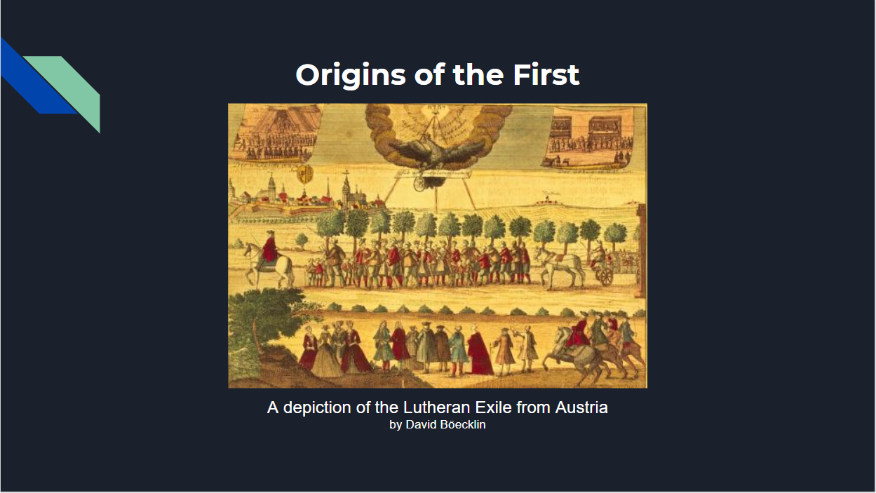 Having more pleasing visual aides also enabled me to remain confident while speaking. I usually understand the purpose behind images on the screen and that helps me synthesize a somewhat coherent sentence when sharing my research topic to the class.

One of my favorite in-class activities was popcorn speech. Essentially, we were given a one-word hint that is somewhat related to the picture, and our improvised speech began when the photo is projected. When my turn to present came around, I was extremely nervous because public speaking terrifies me. I’ve embarrassed myself before and a repeat would suck.

 However, improv was different from a prepared speech. There was no expectation of what the content could be about. As a result, I could comfortably get creative and have my way. Embedded is an audio file containing my improv speech based on the pictured landfill.

Notice how I am in character of my made-up character. Although I might not have the same gusto as Terry, it’s still just as ridiculous and organized as your average Old Spice commercial.

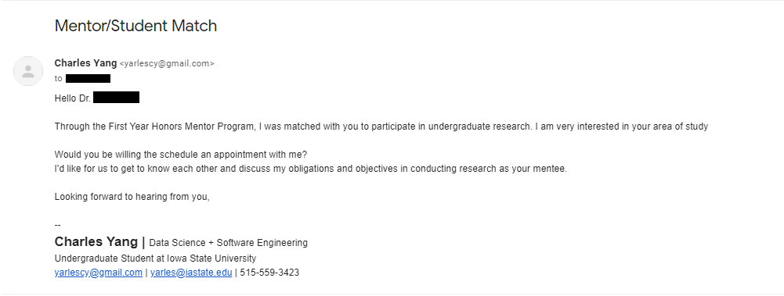 When I attended Waukee High School, I had the privilege to participate in the Waukee APEX program. The program aimed to teach students about workplace ethic and professionalism. The first skill they teach you is email writing. This skill is essential in maintaining a professional work relationship. Learning how to write emails felt weird at first because it seemed so simple at first. However, it is important to have a strong understanding of the context and audience of the email. Below is a professional email written to.

I chose this email because it was important. I needed to reach out to my professor mentor in a manner that made good first impressions. Here I decided to show interest in his work, clearly state my intentions, and sign off professionally. Note my polished signature, adding a degree of professionalism.